Create table

CREATE TABLE [dbo].[Product_pro] (

[Id] INT IDENTITY (1, 1) NOT NULL,

[Name] NVARCHAR (MAX) NOT NULL,

[Price] REAL NOT NULL,

[Image] NVARCHAR (MAX) NOT NULL,

[Product_number] INT NOT NULL,

[Brand] NVARCHAR (MAX) NOT NULL,

CONSTRAINT [PK_Product_pro] PRIMARY KEY CLUSTERED ([Id] ASC)

);

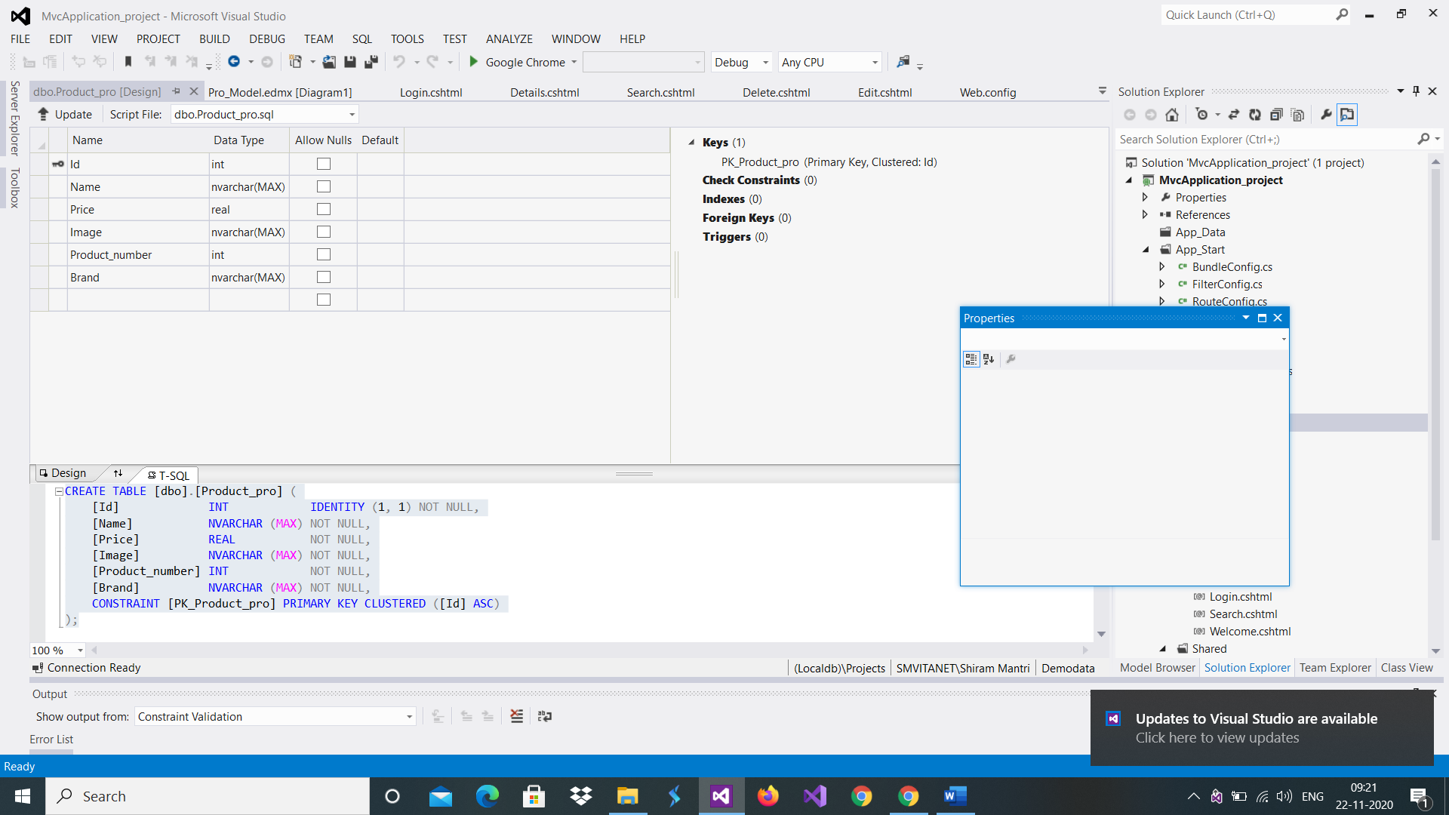

Create table tblUser

CREATE TABLE [dbo].[tblusers] (

[Id] INT IDENTITY (1, 1) NOT NULL,

[FullName] NVARCHAR (MAX) NULL,

[UserName] NVARCHAR (MAX) NULL,

[Password] NVARCHAR (MAX) NULL,

CONSTRAINT [PK_tblusers] PRIMARY KEY CLUSTERED ([Id] ASC)

);

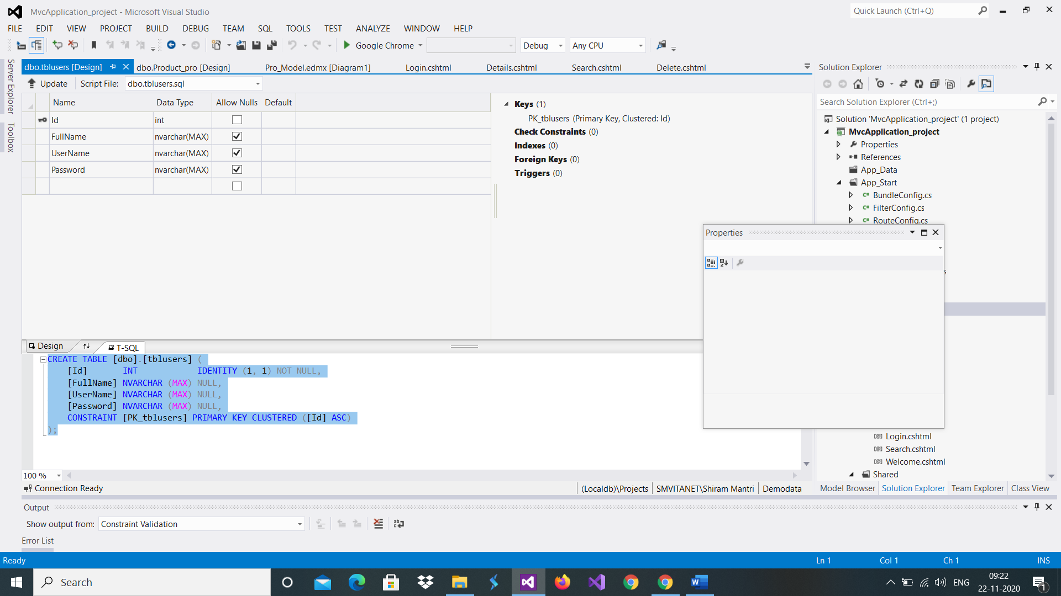

Generate Model from Database select two table.

In my web.config change databse.

Refere this as reference file to do the task